(Approx. 826 words)

GEEK FREE
Shopping for a New Television?
By Joe Callison, Author, GEEK FREE & FOR~GO (For Geeks Only) blogs; Convener, Senior Techies SIG
Seniors Computer Club of Greater Kansas City
https://kcsenior.net/
sencommember00 (at) gmail.com

Labor Day through New Year's Day is the best time to buy the current model year televisions before next year's models are introduced at the Consumer Electronics Show (CES) in early January and available to consumers by spring or summer. Most television manufacturers set the prices that authorized retail dealers can sell their televisions for, so any discounts should be the same wherever you shop but selecting a dealer with a price match guarantee is a good idea. Unfortunately, Amazon does not do price matching according to my source of information.

Next year's new models may have new features but will likely be sold at full price at first. Some of the more important features to consider are listed below. Keep in mind that most television showrooms do not have lighting like you would be viewing the television at home. Sometimes the brightness is adjusted up considerably in the showroom to compensate for the bright lighting and may wash out the color. Be sure to view the television from the same angles that it is likely to be viewed in your home because the capability of viewing angle varies. Built-in speakers rarely sound very good. A separate soundbar is an extra expense but well worth it.

Resolution

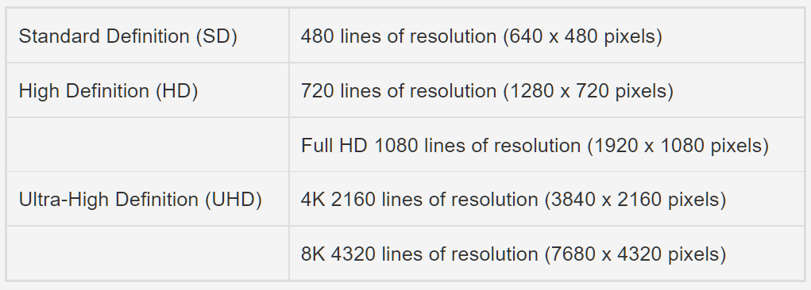

What resolution do you need? It depends on the size of the television and how far you sit from it. The average person with 20/20 eyesight can distinguish dots up to about 350 pixels per inch (ppi) at a normal reading distance of 10-inches. An 8 x 10 photo at that distance would need 9.8 megapixels (Mp) at that ppi. The same 8 x 10 photo displayed on a wall at a distance of 20-inches would only need 170 ppi or 2.3 Mp to appear the same. At 78-inches, it would only need to have 44 ppi. A 40-inch television with Full HD would have about 55 ppi, which would look good at that distance. With the trend to ever-larger television displays often viewed at close distances, more resolution is needed. The following table is based on one manufacturer's dimensions for current 4K models and compares the minimum seating distances for 4K vs. Full HD viewing.

Display Size (Inches) Minimum Distance 4K (Ft) Minimum Distance Full HD (Ft)

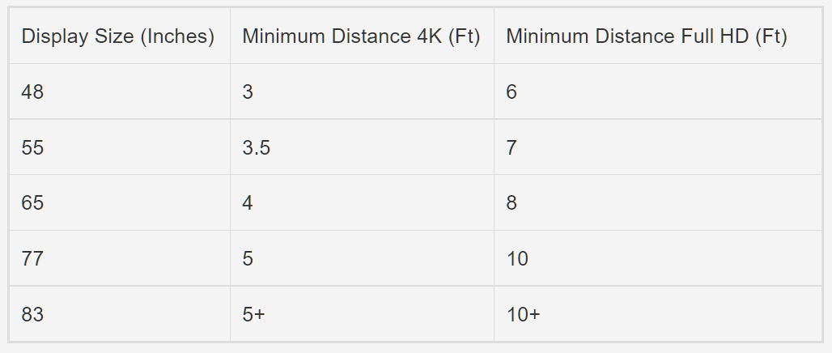

High Dynamic Range (HDR)
Resolution alone does not make a television picture look good. The range of colors produced, from deep blacks to brilliant whites, makes a big difference in appearance. The current technology commonly used is known as HDR. For most people, a Full HD television with HDR will look better than a 4K UHD television without HDR. Therefore, most of the latest 4K televisions now include HDR also.

Refresh Rate
Practically all current televisions will have either a 60 Hz or 120 Hz refresh rate, which is the number of frames of picture information displayed each second. Manufacturers have all kinds of proprietary gimmicks to produce and advertise higher effective refresh rates that trick the eyes into noticing less motion blur. Still, the actual native refresh rates remain the same. The higher than native refresh rates are typically only helpful for high-speed game playing or some types of sports viewing. For other types of viewing, the techniques can appear unnatural. Therefore, it would be desirable to disable the features in the television settings when not needed.

HDMI 2.1
This newest HDMI standard is required for high quality 8K at 60 Hz or 4K at 120 Hz capability without data compression. However, existing DVD players, video cameras, and other HDMI devices will still use the older standard when connected to the television.

LED-LCD vs. QLED vs. OLED
Most existing televisions are liquid crystal displays (LCD) with light-emitting diodes (LED) for backlighting; they are typically only described as "LED" type by manufacturers. Quantum LED (QLED) is a technique by Samsung and others to use LED light to cause a layer of quantum dots in the LCD display to emit light. Organic LED (OLED) is an entirely different display technology than LED-LCD. It has color and backlight emitting diodes at every pixel of the display. It is much more expensive than LED-LCD, has a much richer color and deeper black capability, and can be made in thinner, lighter-weight panels. In addition, OLED tends to be more reflective of ambient light, so it is best with dim room lighting.

ATSC 3.0
Eight stations in Kansas City have begun ATSC 3.0 broadcasts, also called NextGenTV or 4K over-the-air, for people receiving television by antenna instead of cable or fiber. An ATSC 3.0 tuner is required to take advantage of it.
https://www.watchnextgentv.com/

If you have an older 4K television with an ATSC 2.0 tuner, an external NextGenTV tuner box could be purchased to receive 4K over-the-air broadcasts.

